

Highways & Transportation

«PAO_DESC» «PAO_START_NO»
«STREET_NAME»
«LOCALITY_NAME»
«TOWN_NAME»
«POSTCODE»
Civic Hall
Calverley Street
Leeds LS1 1UR
Contact: Wayne.Donnelly@leeds.gov.uk
Our reference: HW/GH/23022324
Tel: 0113 222 4407

06/09/24
Dear Occupier,

Wynmore Avenue, Bramhope
Leeds Road to Tredgold Avenue

We are pleased to inform you that the above footway has been scheduled to be resurfaced by Leeds City Council.

The resurfacing will commence on Monday, 23rd September and should take 6 weeks to complete (weather permitting).

The work will be carried out under a give and take system between the hours of 8.00 and 15.30, Monday to Friday.

Please can any vehicles belonging to yourselves, or any visitors be parked off the road between the hours of 8.00 and 15.30.

If you live on the above road or use it for access, please understand access will be heavily restricted and will not be possible at times.

Please can you ensure any hedges/vegetation within your property are trimmed back to the boundary line at the back of the footway.

The supervisor for this work is Gary Hanakin and he can be contacted through 0113 222 4407.

Your cooperation will minimise the disruption to yourselves and ensure the works are completed in as short a time as possible.

Thank you in advance for your patience and cooperation.

Yours sincerely

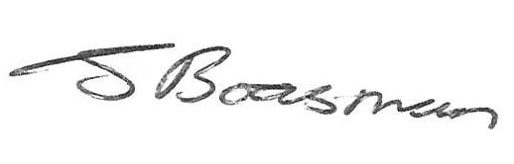
Jason Boasman
Highway Maintenance Manager

