

Highways & Transportation
Civic Hall
Calverley Street
Leeds LS1 1UR
Contact: Wayne.Donnelly@Leeds.gov.uk
Our reference: HW/GH/23022292
Tel: 0113 222 4407

06/09/2024
Dear Occupier,

Leeds Road, Bramhope
St Giles Garth to Moorlands Farm.

We are pleased to inform you that the above carriageway has been scheduled to be resurfaced by Leeds City Council.

The resurfacing will commence on 23/09/2024 and should take 10 days to complete (weather permitting).

Works will be carried out under traffic signals each day between 09:30 – 15:30 on weekdays and there will be a point closure of Church Hill. Access will be maintained to the Hotel and Staircase Lane although there will be times during each process where access will be restricted. There will be no access onto Staircase Lane from Hall Drive.

Please can any vehicles belonging to yourselves, or any visitors be parked off the road between the hours of 09.30 and 15.30.

If you live on the above road or use it for access, please understand access will be heavily restricted and will not be possible at times.

The supervisor for this work is Gary Hanakin and he can be contacted at 0113 222 4407.

Your cooperation will minimise the disruption to yourselves and ensure the works are completed in as short a time as possible.

Thank you in advance for your patience and cooperation.

Yours sincerely

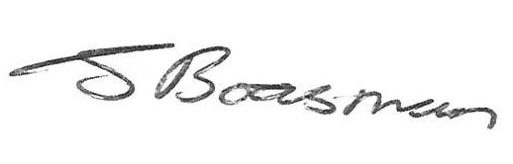
Jason Boasman
Highway Maintenance Manager

