

Connecting Leeds

Highways and Transportation
Leeds City Council
Merrion House, Merrion Way
Leeds LS2 8BB

5 July 2024

Dear Resident / Owner,

Lawnswood Roundabout Improvement Scheme – Update meeting Thurs 18 July 2024
The project team would like to invite you to a public meeting, at which an update will be given on the latest design, and the next steps for the Lawnswood Roundabout Improvement Scheme. The meeting will take place in the Cookridge Suite at Weetwood Hall Estate, 18 July 2024, 6:30pm-8:00pm. Starting at 7pm, there will be a presentation and then question and answer session.
Between November 2021 and January 2022, Leeds City Council consulted on plans to improve Lawnswood roundabout. The plans included introducing traffic signals at the roundabout, alongside signalised crossing facilities for pedestrians and cyclists, and new segregated cycle tracks. The plans are designed to improve road safety for all users, provide safer and more attractive facilities for walking and cycling, and facilitate the prioritisation of buses.
Since this consultation, Leeds City Council has continued to develop the scheme, securing approval of an Outline Business Case in December 2023. A Full Business Case is currently undergoing appraisal by the West Yorkshire Combined Authority. Subject to the relevant approvals being received, the main construction works are expected to begin in January 2025.
If you have any questions, please contact me using the details provided below.

Yours faithfully

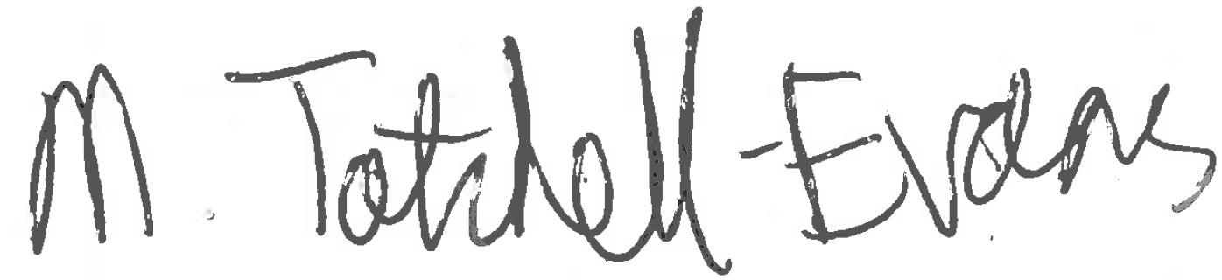
Morgan Tatchell-Evans (pronouns: he/him)
Transport Strategy, 8th Floor East
Leeds City Council
Merrion House
110 Merrion Centre
LEEDS
LS2 8BB
Email: morgan.tatchellevans@leeds.gov.uk
Telephone: 0113 37 83655

