|  |  |
| --- | --- |
| «2»  «3»  «4»  «5»  «6»  «7»  «8» | Yorkshire Water Services  PO Box 52  Bradford  BD3 7YD  Tel- 0345 1 24 24 24    When telephoning or writing  please quote ref: «1»  Scheme Ref- Capital YW.204685 |
|  |  |

29 May 2024

«9»

**Notification of upcoming work on Old Pool Bank**

I’m writing to let you know we’re about to start work to replace around 1400m of cast iron water main. This £500,000 investment will improve water quality for customers in the area and improve water pressure.

From Monday 10th June 2024 our contract partners United Living will start this work. Our usual working hours will be 08:00 to 18:00, in order to get this work complete as quickly as possible we will be working 7 days a week.

We will be completing this work in 4 sections, detailed below –

**Old Pool Bank (Bottom Side)**

Starting 10th June till 28th July we will be working on the bottom side of Old Pool Bank, shown below. Due to the location of this work, we will have to close this road, access to businesses and properties will be maintained via a signed diversion. Our site team will liaise with residents affected directly.

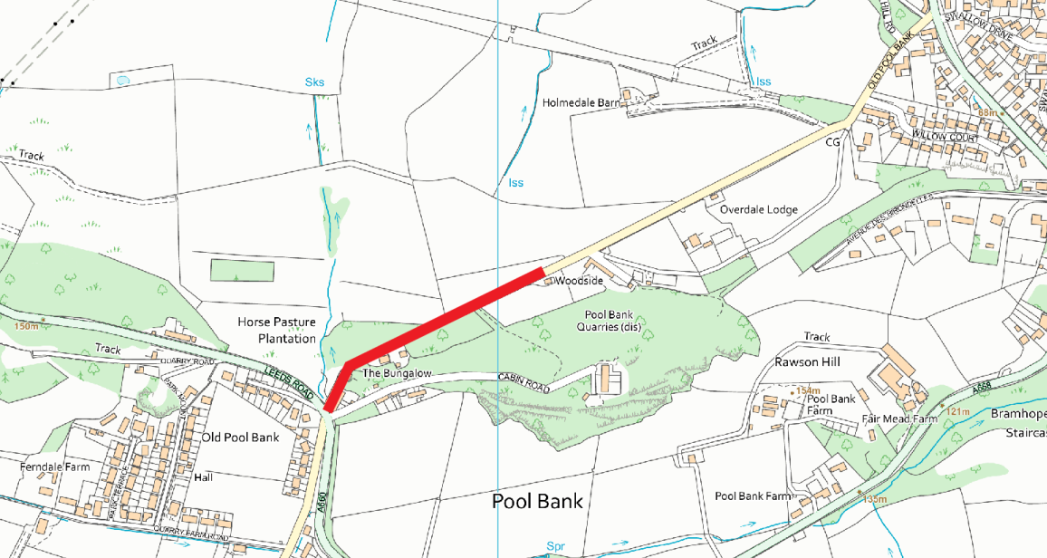

**Leeds Road from the junction with Old Pool Bank to the junction of Quarry Road**

Starting 29th July to 22nd September we will be working on Leeds Road. Due to the location of the work, we will have temporary traffic lights around our working area on Leeds Road and at the junctions with Upper Old Pool Bank and Old Pool Bank.

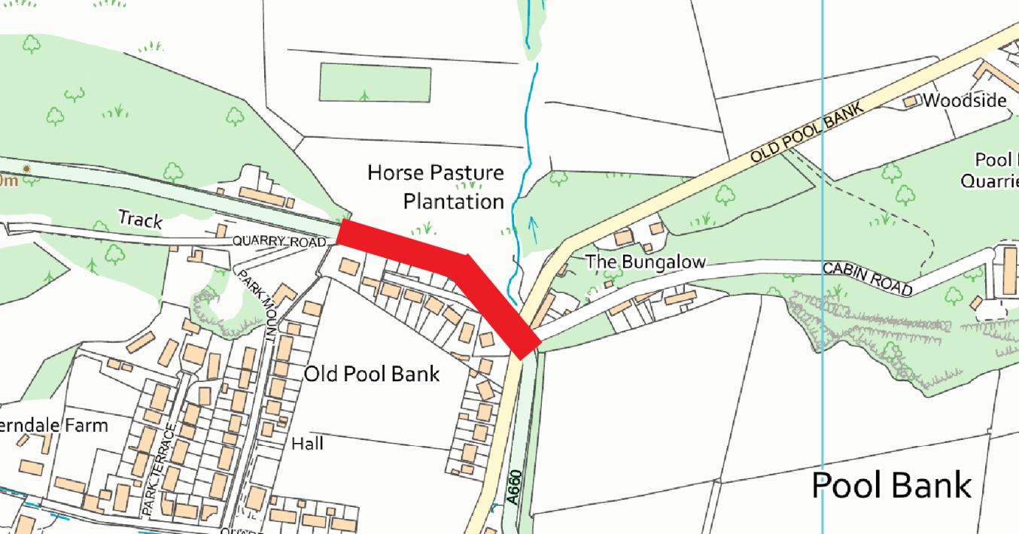

**Old Pool Bank (Top Side)**

Starting 29th July to 20th October we’ll be working on the top section of Old Pool Bank, from the junction with Leeds Road to the junction with Quarry Farm Road, shown below. Due to the location of this work, we will have a road closure in place. Access to properties will be maintained via a signed diversion. Our site team will liaise with residents affected directly.

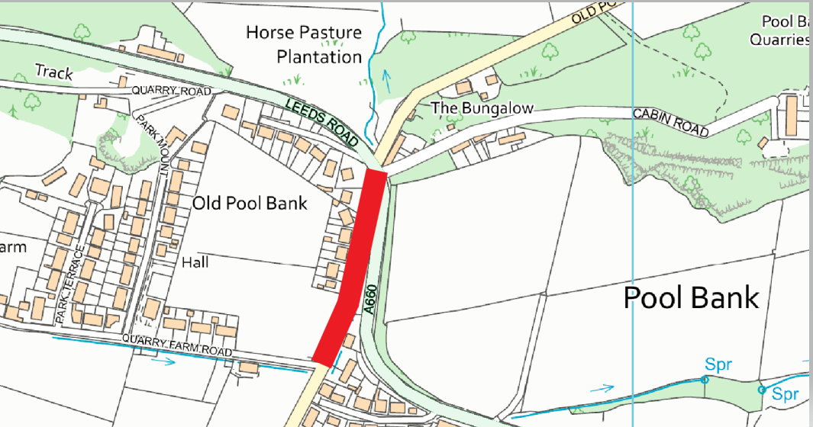

**Quarry Road**

Starting 21st October to 3rd November we’ll be working on Quarry Road, residents affected by this work will be contacted directly.

If you have any questions about this work, please contact the Customer Experience team on 0344 848 1099 quoting Capital YW.204685 (lines are open 8am-5pm Monday to Friday).

Yours sincerely

Becky Page

Customer Liaison Advisor

Customer Experience (Capital)

Yorkshire Water Services