

|  |  |
| --- | --- |
| **The Householder** | **Environmental Services**  Newmarket House  Newmarket Approach  Leeds  LS9 0RJ |
|  |  |
|  | Date: March 2024 |
|  | Ref: AWC Phase 1a |

Dear Householder,

**Your black and green recycling bin days are changing**

We are making changes to your bin collections which will mean your green recycling bin will be emptied every two weeks. You will have your green bin emptied one week and the black green emptied the next. You may hear this referred to a “fortnightly collections” or “alternate week collections”. This will bring your street in line with the majority of Leeds.

This new arrangement begins on **[INSERT DATE]** with your black bin. The week after will be your green bin and so on.

Your new black and green bin collection day will be **[INSERT DAY]**

If you receive the brown bin (garden waste) service, there will be no change to this collection day.

Recycling rates have increased in streets where residents receive more regular green bin collections. You will find enclosed a useful green bin leaflet showing you what can be recycled. We suggest putting this somewhere convenient, maybe on your fridge or a cupboard door.

If you don’t currently have a green bin for recycling, you can order one by visiting [www.leeds.gov.uk/requestbins](http://www.leeds.gov.uk/requestbins) or scanning the QR code below.

Your usual collection time may change, so please put your bin out before 6:30am on collection day (the night before is okay) and return it to your property the same day, as soon as possible after it has been emptied.

A printable calendar for all your bin collection dates is available at: [www.leeds.gov.uk/mybinday](http://www.leeds.gov.uk/mybinday) or download the handy Leeds Bins app to get bin day reminders straight to your phone.



SCAN TO CHECK YOUR NEW DATES

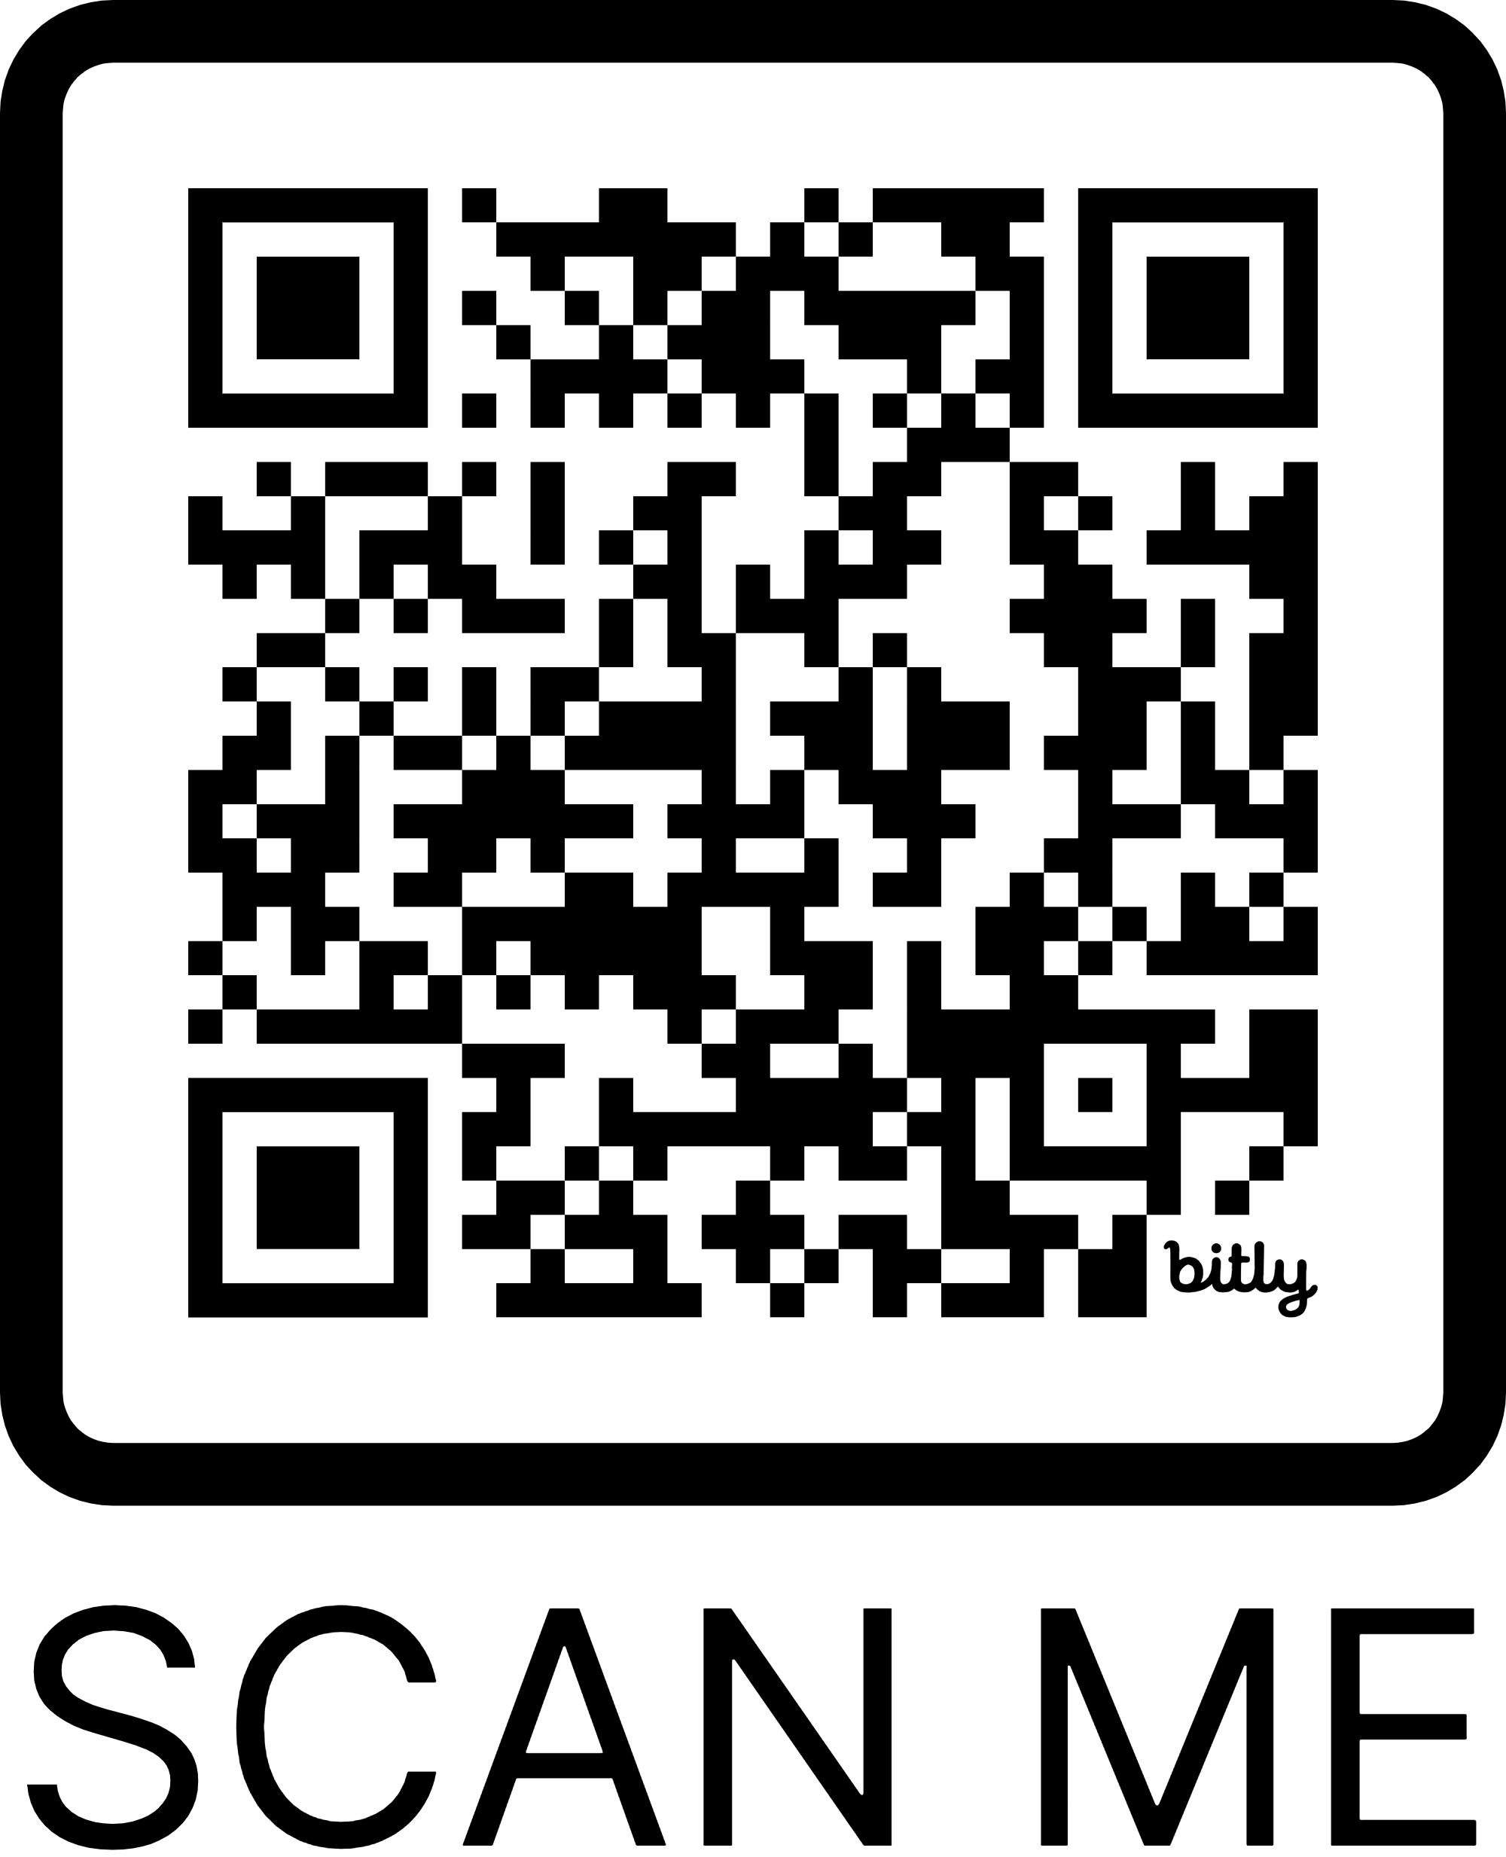

SCAN TO

ORDER A BIN

Regards,

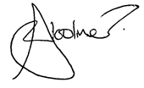

**John Woolmer**

Chief Officer (Environmental Services)

This information constitutes formal notification of a change in your refuse   
collection system as required by the Environmental Protection Act 1990 (section 46).